

**Thank You!**

**Why Donate Now?**

**Donate Online**

Go online to

[www.torreyhillspta.com](http://www.torreyhillspta.com)

* **Keep it Simple**

Donating NOW allows the PTA to have fewer fundraisers.

* **Tax Deductible**

The Torrey Hills PTA is a non-profit organization and any donation is 100% tax-deductible.

* **Guarantee this year’s programs**

Receiving donations early ensures that we can determine grants for technology and classroom materials, and offer all our education and school community programs.

* **Your donation makes a huge difference!**

**For more information about the Torrey Hills PTA**

Go online to

[www.torreyhillspta.com](http://www.torreyhillspta.com)

**Donate by Check**

Fill out your information below and enclose it in an envelope.

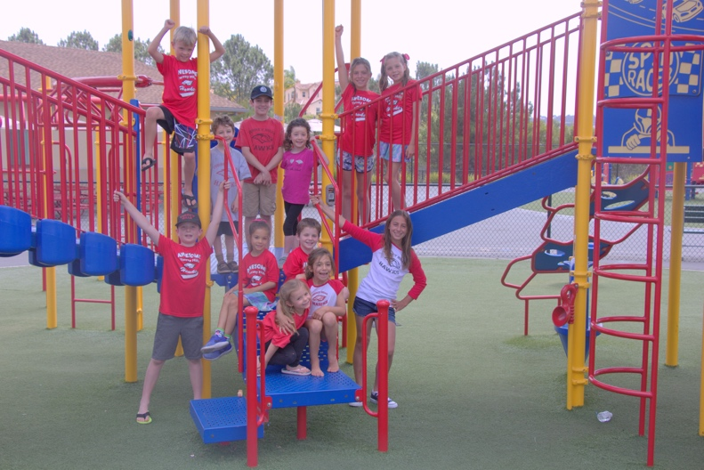

Compete below return to the PTA Mailbox at the main office.

Parent First Name _______________________

Last Name _____________________________

Phone Number _________________________

Email address __________________________

Address _______________________________

City/ZIP ______________________________

Student(s)name/grade/teacher ____________

_____________________________________

_____________________________________

Amount_______________

# Torrey Hills Annual PTA Giving Campaign

**Your donation is tax deductible.**

**Our tax ID is #03-0460340.**

**Corporate Matching**

Double your donation and double your impact! Many companies will match your donation amount at no cost to you – please check with your employer!

**Make Your Donation Today!**

**Yes, I want to donate!**

Go online to:

[www.torreyhillspta.com](http://www.torreyhillspta.com)

Our limited-edition items are available only through the Giving Campaign:

**Torrey Hills Backpack**

For **Raptor** **Level** and **Owl Level and above**!

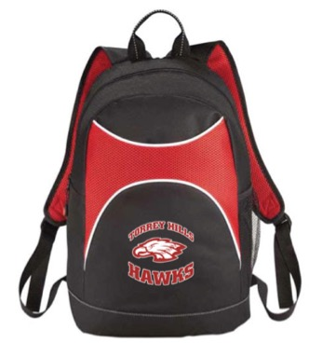

**Personalized Torrey Hills T-shirt**

All **Raptor level and above** family last names will be added to the back as a campaign sponsor!



* **$2,000 and above – Hawk Level**
  + Torrey Hills Reserved parking spot for the school year
  + One of each exclusive listed below
* **$1,000 and above – Eagle Level**
  + Limited edition Torrey Hills backpack
  + Personalized Torrey Hills t-shirt
  + Torrey Hills hat
  + 100 carnival tickets
* **$500 and above - Owl Level**
  + Limited edition Torrey Hills backpack
  + Personalized Torrey Hills t-shirt
  + Torrey Hills car magnet
  + 50 carnival tickets
* **$250 and above - Condor Level**
  + Limited edition Torrey Hills backpack
  + Personalized Torrey Hills t-shirt
  + 25 carnival tickets
* **$150 and above - Raptor Level**
  + Personalized Torrey Hills t-shirt
* **$75 and above - Falcon Level**
  + Torrey Hills hat
  + Torrey Hills car magnet

Torrey Hills Annual Giving Campaign is designed to raise funds for Torrey Hills Elementary School. 100% of your donation stays at Torrey Hills. We are asking for a minimum donation of $75.00 per child. **Our** **goal is 100% participation**, so please give any amount that you can. Every dollar counts!

**Your PTA Donation at Work**

* iPads, Chromebooks & integrated technology for classrooms
* Family Events – Taco Night, Bingo Night & Movie Night!
* Science tools and equipment
* Art supplies and tools
* Playground equipment and lunch benches
* Field day
* Literacy materials for classroom
* Ocean Week by Birch Aquarium
* School Assemblies and Programs – Biztown

– Thinkabit at Qualcomm

– Imagination Machine

Go online to [www.torreyhillspta.com](http://www.torreyhillspta.com)

**Giving Levels and Rewards**

**Giving Campaign Exclusives**

**The Campaign**

**Donate Online**